Game Design Document

Fill up the Following document

1. Write the title of your project.

Stepping Stones to my Villa

1. What is the goal of the game?

The Player has to escape from all the threats to his life such as barricades and birds and score as many points as possible.

1. Write a brief story of your game?

This is an Infinite Runner Game. In this Game, there is a Player in this game who has to escape from all the threats to his life. There are birds and barricades in the game. The player has to slide down to protect himself from hitting the birds and has to jump over the barricades. The goal of this game is to score as many points as possible by collecting coins.

1. Which are the playing characters of this game?

There is only one playing character in my game. His name is Harvey. He can jump by pressing the “Up Arrow” key and slide down by pressing the “Down Arrow” key.

1. Which are the Non-Playing Characters of this game?

There are birds and barricades in the game. On hitting these things, the player gets hurt and the Game gets over.

Draw your imagination of this game. What does this game look like?

* Draw the game either on your computer or on paper,
* Add images of scenes of the game to show each of the playing and non-playing characters at least once.

(Ma’am I haven’t added the images to the sprites till now)

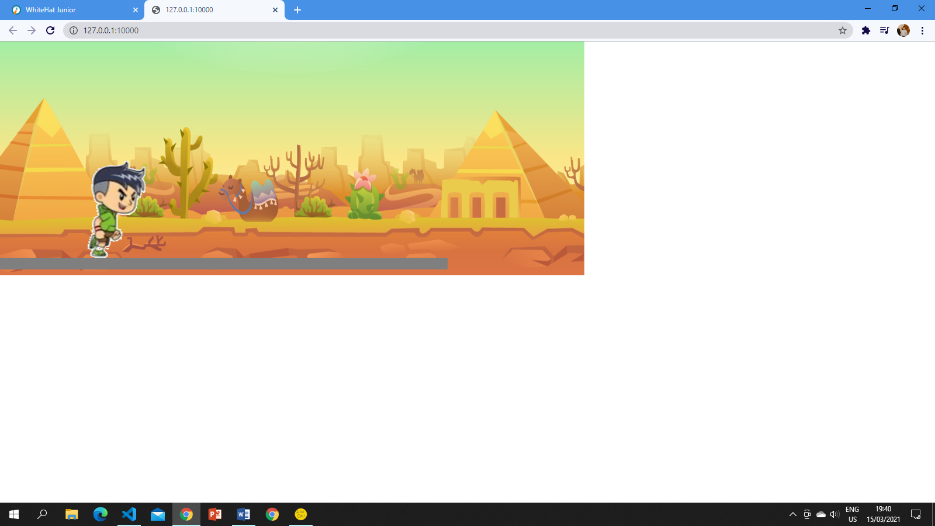

How do you plan to make your game engaging?

I plan to keep the game engaging by keeping score which increases when the person collects coins. Also, another way of keeping my game engaging is by increasing the difficulty of game after some frames.